MINUTES OF THE INHE-BAMENDA, CAMEROON MEETING ON 14th MARCH 2020 WHICH TOOK PLACE AT DREMLAND RESTAURANT, COMMERCIAL AVENUE BAMENDA.

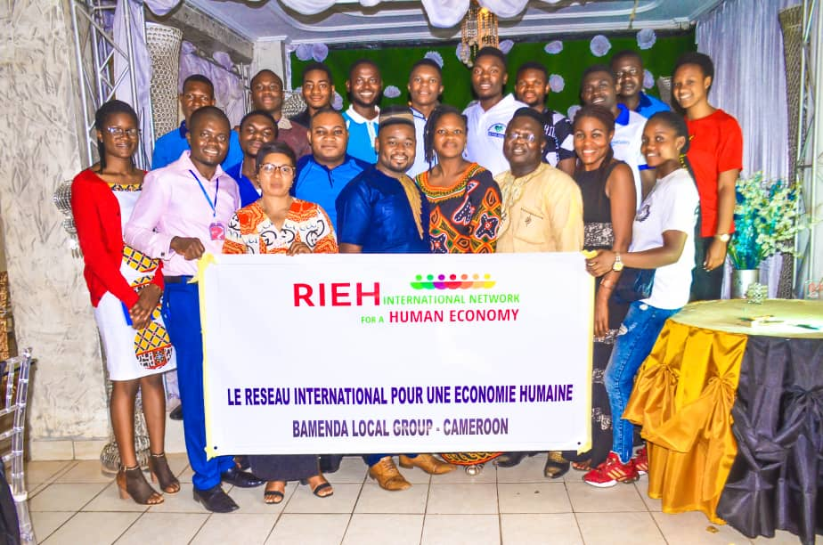
Members of INHE-Bamenda Local Group

The meeting started at 10:45 am with an opening prayer done by Miss Bih Belvian Chofor of Belvy's home for the elderly Cameroon. Eleven (11) organisations were present for the meeting (see appendix 2) and cMr. Oju Slyvester from team Didacticians, chaired the meeting. The opening prayer was followed by a word of welcome from the chairman who thanked members for their massive turnout and craved on their indulgence to keep up with the recorded enthusiasm and work towards fostering the concept of the Human Economy in Bamenda, North West region and Cameroon as a whole. Self introduction was then conducted with new members commencing, followed by existing members of the local group. Self introduction consisted of ; the name of the organisation, name of its focal person(s) and the main objectives and activities of the organisation. Worthy of note is that, four (04) new organisations joined the existing organisations of the INHE-Bamenda Local Group on this date, namely :

1) Belvy’s Home for the Elderly
2) Nkwenti’s Foundation
3) DiDA Clothing
4) Pro-Educo Foundation

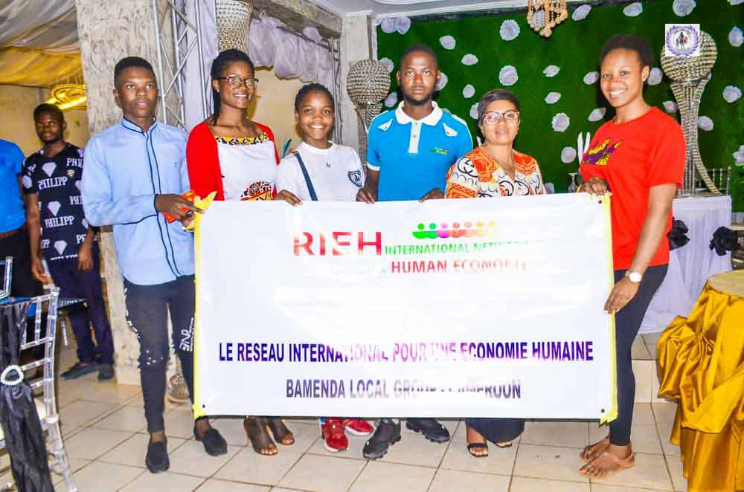
GIC and TeenAlive accompanying the four (04) New Organisations that joined INHE-Bamenda Local Group.

We then moved to the reading and adoption of the previous meeting (launching of INHE-Cameroon, in Yaoundé on the 21st of December 2019). This was merely a formality for the existing members given that they already had the minutes circulated to them and they took part in its adoption before onward forwarding to the head office. However, it permitted the new organisations to be updated on what had happened so far. Next was a presentation on the « Guidance Note on the Operation of an INHE local group » by the team lead of CamCoSO, Mrs Ndi Euphrasia. She expatiated on the translated (into English) version of the « Note d’orientation pour le fonctionnement d’un Groupe local du RIEH » (see appendix 3).

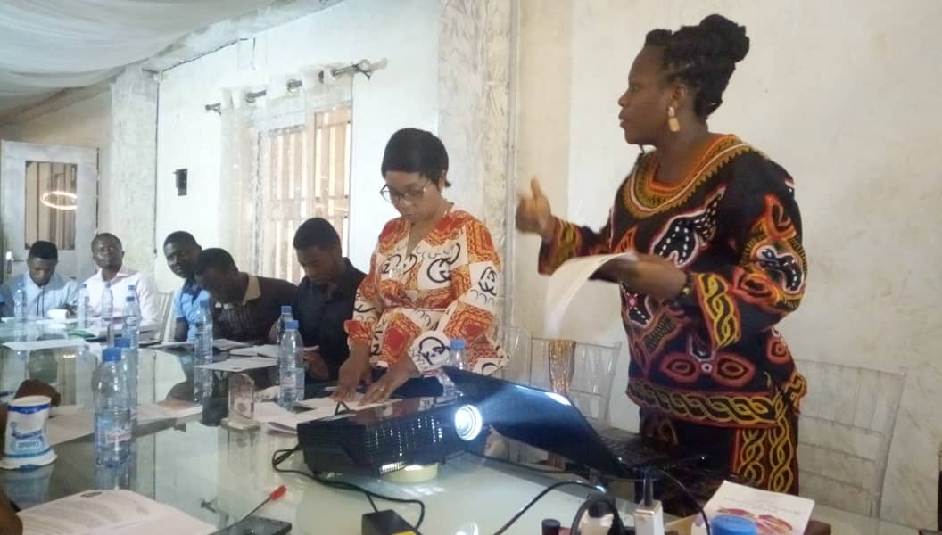
Sixth on the agenda was Elections and thereafter installation of the governing officials of INHE-Bamenda Local Group. The elections were coordinated by TeenAlive and MAYA, while Team Didacticians and Rural Doctors handled the installation of the elected officials. Strict reference was made to the local group governing constitutions as recommended in the ‘Un Groupe local est doté de’ subsection of the « Note d’orientation pour le fonctionnement d’un Groupe local du RIEH ». Below is the list of elected officials and their posts of responsibility ;

Post | Sub-category | Elected Official |  | Remark
 |  | Organisation | Individual
Facilitator |  | CamCoSO | Ndi Euphrasia
A committee of 3 to 7 members, volunteers, in charge of programming activities |  | 1. Team didacticism  2. MAYA  3. ROHER-CAM  4. Better Health  5. Rural Doctors  6. GIC  7. Teen Alive | 1. Mr. Oju Sylvester  2. Abimnui Julius  3. Ngeh Etienne Ngeh  4. Ngong Andy Jones  5. Tebe Rogerson  6. Mercy yeafon  7. Mbain Doreen | We decided to take the upper limit of seven (07), so as to make the programming of activities as inclusive as possible
Organisation carrying out the administration of the Local Group |  |  |  | Still to be elected (at the moment only one organisation met the criteria- CamCoSO). The others don’t yet have a physical address in Bamenda, Bank Account etc. Given that the facilitator already comes from CamCoSO, we thought it wise to give another organisation this position (please advice). Feel free to advice us on what to do, given that we obviously need an organisation to start carrying out the administrative functions of INHE-Bamenda.  We however, decided that it should be between Team Didacticians and Rural Doctors
Resources: membership fees, income from books, donations and legacies, grants (from donors), contributions from the INHE, self-financing | 1.Financial Secretary  2. Treasurer | 1. Rural Doctors  2. Team Didacticians
Communication Desk | 1.Facebook Page  2.Twitter handle  3. LinkedIn Accout  4. Instagram Page  5. Minutes Sectary  6. Public Relation Officer | - Better Health  - GIC  - TeenAlive  - DiDA Clothing  - Belvy’s Home for the Elderly: Nkwenti’s Foundation  - GIC: MAYA | 1.Andy Jones  2. Mercy Yeafon  3. Ngonga Linda  4. Tessy Sunju  5. Bih Belvian Chofor; Fedel Nkwanti  6.kajum Lenshina Nenne  ; Mbangmbang Marcel.
Webmaster |  | 1.Team Didacticians  2. TeenAlive | 1.Mr Dchuningang Alfred  2.Mme Mbain Doreen

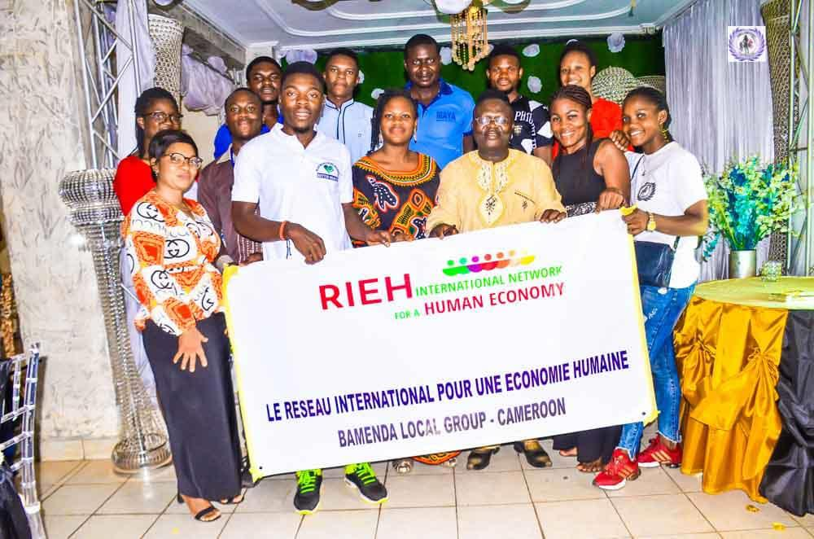
INHE-Bamenda Local Group Elected Executives
The meeting rounded up with a closing remark from the chairman, photo taking and refreshment.

NB: It was unanimously agreed that; item 8 - Action plan for 2020 and beyond, be taken home as a assignment to be deliberated upon in our respective organisations and discussed concretely in our next meeting.

